**Module 1 Challenge**

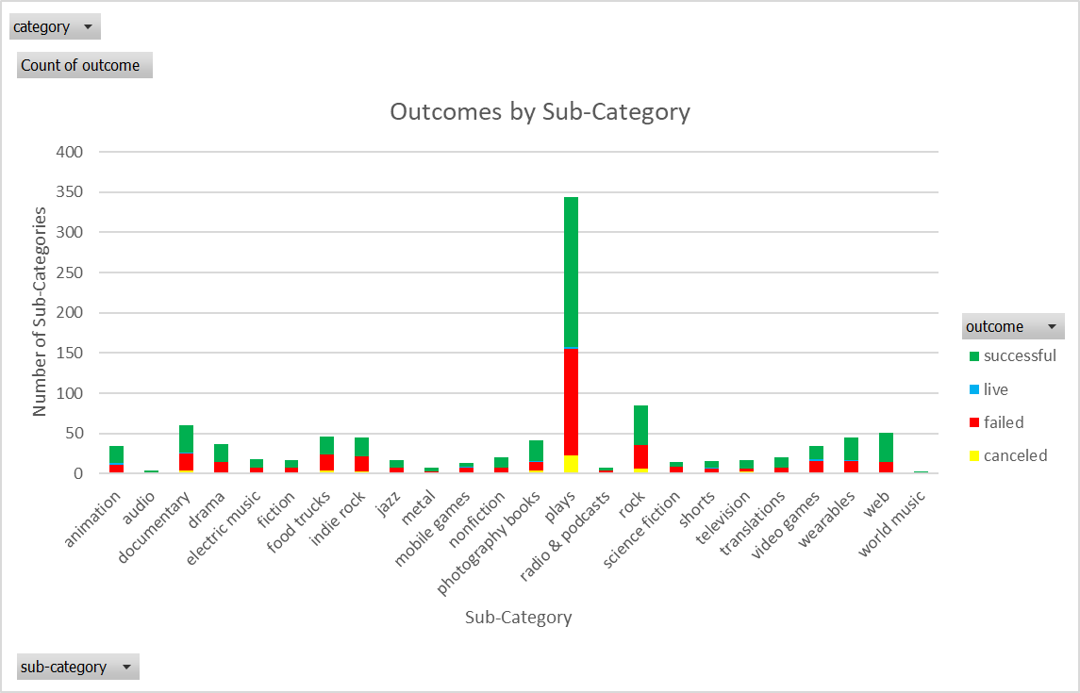

From the three graphs, we deduce that the projects tend to succeed more often than fail even when including projects that were canceled. However, its still risky to donate using crowdsourcing given the high fail rate. Yes, projects succeed more than they fail, but the failure rate is still noticeable. The first graph shows that “film & video,” music, and theatre, have the most projects. The second graph confirms what the first graph states, with plays being the most popular project. Judging from the third graph, we do observe a higher success rate during the summertime in comparison to other seasons.

The graph for Sub-Categories is hard to read given the large amount of information in axis. There are however certain limitations within the dataset. A useful dataset needs to have large sample. The dataset is grand, but when divided by categories the benefits of a large sample is diminished. Take for example journalism, there are only four projects in that category and all are successful. When dataset is further divided by sub-category, the flaws are undeniable. Sub-Categories such as world music, mobile games, audio, radio & podcast, have small samples. Information cannot be inferred with such a small sample.

I think the biggest factor of whether a project succeeds or not, is funding. Therefore, basing how much was pledged is more important than how many people supported it. The percent pledge is the amount needed for the project to succeed divided by the amount the people actually donated .I chose average percent pledged to because the raw data almost implies that any project whose average percent pledged is less than 100, will fail and the pivotable confirms. Instead of using how many people decided to donate, how much was donated makes more sense.

|  |  |  |  |  |  |
| --- | --- | --- | --- | --- | --- |
|  |  |  |  |  |  |
| **Average of Percent Pledged** | **Column Labels** |  |  |  |  |
| **Row Labels** | **canceled** | **failed** | **live** | **successful** | **Grand Total** |
| animation | 34.96 | 44.05 | 75.12 | 333.88 | 224.62 |
| audio |  |  |  | 150.63 | 150.63 |
| documentary | 70.52 | 53.17 | 21.19 | 300.39 | 193.88 |
| drama | 10.63 | 56.34 | 56.19 | 313.35 | 206.68 |
| electric music |  | 37.68 |  | 379.55 | 227.61 |
| fiction | 38.84 | 54.68 |  | 339.86 | 204.73 |
| food trucks | 50.41 | 49.63 |  | 392.72 | 213.78 |
| indie rock | 30.19 | 51.24 |  | 285.09 | 169.36 |
| jazz | 18.85 | 29.13 |  | 467.21 | 286.22 |
| metal |  | 45.76 |  | 320.15 | 202.55 |
| mobile games |  | 51.94 | 36.13 | 180.81 | 90.38 |
| nonfiction | 32.90 | 40.49 | 1.73 | 365.93 | 239.75 |
| photography books | 61.27 | 46.86 | 1.27 | 268.19 | 184.16 |
| plays | 45.76 | 49.56 | 31.40 | 314.46 | 193.20 |
| radio & podcasts |  | 40.07 |  | 176.31 | 108.19 |
| rock | 45.93 | 47.86 |  | 319.98 | 204.59 |
| science fiction |  | 39.78 |  | 249.74 | 114.76 |
| shorts | 24.00 | 69.92 | 58.25 | 334.61 | 215.21 |
| television | 47.38 | 52.91 |  | 237.20 | 171.18 |
| translations |  | 32.57 |  | 242.78 | 172.71 |
| video games | 27.18 | 50.73 | 59.21 | 480.32 | 259.20 |
| wearables |  | 55.78 | 58.97 | 282.67 | 197.03 |
| web | 64.48 | 57.07 | 62.23 | 331.07 | 250.87 |
| world music |  |  |  | 207.92 | 207.92 |
| **Grand Total** | **45.90** | **49.29** | **44.82** | **317.27** | **200.44** |

The three previous graphs tell us how many succeeded and failed meanwhile this chart shows why certain projects failed.